FOR IMMEDIATE RELEASE
November 29, 2016
Jen Steller | Communications Coordinator
jen@downtownLS.org | 816-246-6598
www.downtownLS.org
_____________________________________________________________________________________________ ______________
New Shopping Event, Hometown Holiday, Happening in Downtown Lee’s Summit

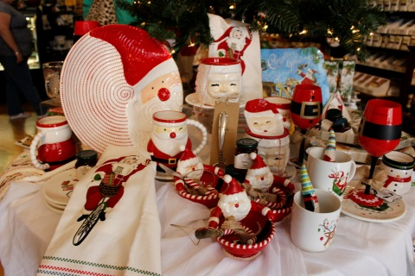
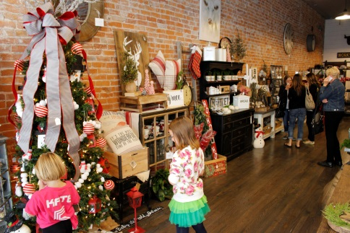
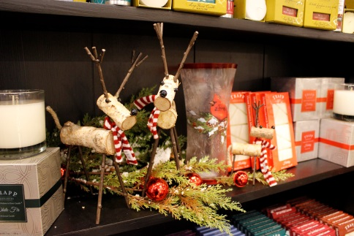
Head to Downtown Lee’s Summit on Dec. 2-3 for Hometown Holiday where the friendliest merchants around will help you find those perfect holiday gifts. Check out all the wonderful gift and decorating ideas featured in the shops in Downtown Lee’s Summit. Enjoy classes taught by local experts and business owners while shopping for the holidays. Two lucky shoppers will win a Downtown Lee’s Summit gift card ($50 or $100)! Dine and unwind at one of 15+ downtown restaurants, pubs and cafes.

Other fun and festive activities include a free gift wrapping station and photos with Santa on Saturday. A free gift wrapping station will be provided at Budget Blinds from 12-4pm on Saturday, courtesy of Lee’s Summit Community Church. Santa Claus will be visiting GOT Art Gallery from 3-5pm for photos with children of all ages.

Downtown Lee’s Summit gift cards will be available for purchase at the Downtown Lee’s Summit Main Street office (13 SE 3rd St.) on Saturday from 10am-5pm. They make great gifts for anyone one your list!

Hometown Holiday Saturday Class Schedule:

10AM – Holiday Bow Making
Henry’s Antiques & Tea Room
401 SE Douglas St.

11-11:30AM – Free Scrapbook Layout
Scrapbook Boutique
100 SE 3rd St.
11AM – DIY Amy Howard Painting Demonstration
Very Violet Boutique
20 SW 3rd St.

1PM – Awesome Christmas Cards
Summit Video Services
21 SE 3rd St.

2-4PM – Family Paint ($15/person)
GOT Art Gallery
18 SW 3rd St.

Participating Stores:
- @Jolly’s
- A Thyme for Everything
- Bar-istro
- Blue Heron Design
- Budget Blinds of Lee’s Summit
- The Cigar Room
- GOT Art Gallery
- Henry’s Antiques & Tea Room
- KD’s Books
- The Living Stone
- Luxxe Apparel
- Razzberry Wimzy
- Red Door Wine Store
- Scrapbook Boutique
- The Sports Scene
- Summit Video Services
- Third Street Social
- Timekeeper’s Clock Shop
- Very Violet Boutique
- Whistle Stop Coffee & Mercantile

Free public parking for Downtown Lee’s Summit events is always available at the parking garage located at 2nd and Green streets.
—END—
MEMBERS OF THE MEDIA (not for publication):
To reach DLSMS Executive Director Donnie Rodgers, Jr.: donnie@downtownls.org.
To reach DLSMS Assistant Director Ashley Nowell: ashley@downtownls.org.
To reach DLSMS Events & Promotions Director Julie Cook: julie@downtownls.org.
To reach DLSMS Communications Coordinator Jen Steller: jen@downtownls.org.
Or call 816-246-6598. High-resolution photos and logos available upon request.
ABOUT DOWNTOWN LEE’S SUMMIT:
Downtown Lee’s Summit is a multiple state and national award-winner for excellence in downtown revitalization, including the 2010 Great American Main Street Award®, which the National Trust Main Street Center gives to only five communities across the nation every year.
Rich in history, Downtown Lee’s Summit is listed on the National Register of Historic Places. Its strong ties to the railroad continue to this day — visitors can hop on a passenger train and arrive at the Amtrak station in Downtown Lee’s Summit for a memorable trip. With more than 40 distinctive retail shops, and many restaurants and bars ranging from upscale to laid-back, Downtown Lee’s Summit is an eclectic and fun place to visit. New residential lofts and adjacent historic neighborhoods also make Downtown Lee’s Summit an exceptional place to call home. A unique combination of preservation of history and place, with progressive attitudes and entrepreneurship, make Downtown Lee’s Summit a great place to live, shop, eat and play.

