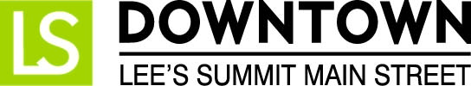
FOR IMMEDIATE RELEASE
January 19, 2017
Jen Steller | Communications Coordinator
jen@downtownLS.org | 816-246-6598
www.downtownLS.org
_____________________________________________________________________________________________
Downtown Lee’s Summit Hosts Chocolate Crawl for a Cause Event
Donations to benefit Lee’s Summit Social Services

Downtown Lee’s Summit Main Street is hosting its annual Chocolate Crawl for a Cause event starting at noon on Saturday, February 4 in Downtown Lee’s Summit, MO.

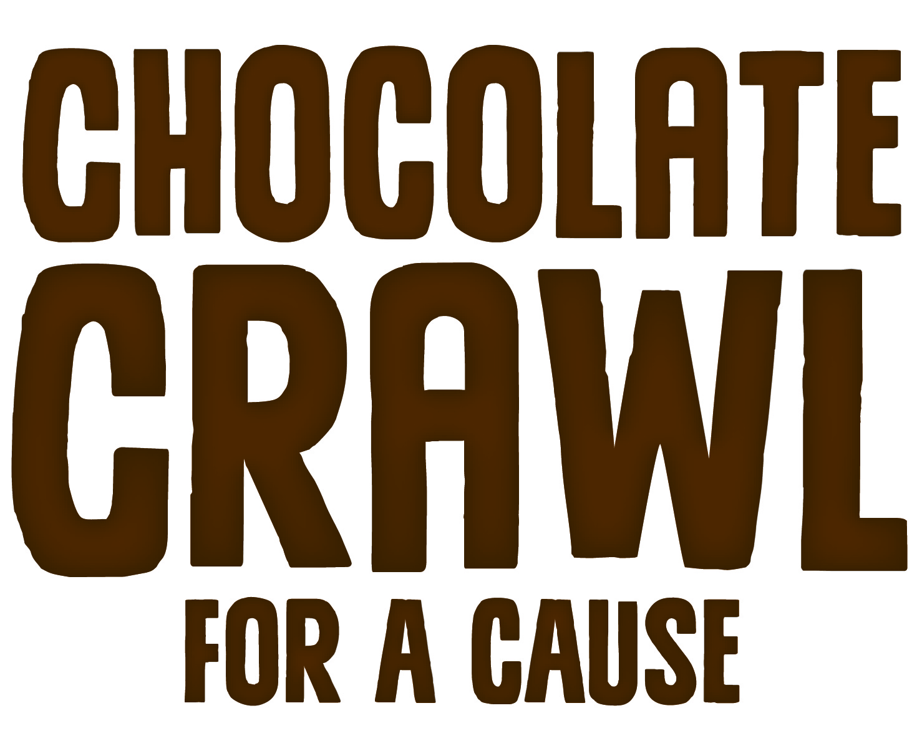
Again this year, participants are asked to bring a small donation to benefit Lee’s Summit Social Services this winter season. Donation preferences are monetary and non-perishable food items and can be dropped off at GOT Art Gallery from 12-4pm on the day of the event. In return for the gift, the first 750 shoppers will be given a special Lee’s Summit chocolate bar (courtesy of MCC/Longview and Lee’s Summit Chamber of Commerce), an event wristband, and a downtown map.

The wristband allows for participation in promotions and discounts that day as a special thank you from Downtown Lee’s Summit shops and restaurants for the donation to our community. Participating stores will be highlighted on the downtown map given to shoppers so they can easily find the businesses providing promotions and discounts. Shoppers can use the map or follow the balloons for chocolate treats, discounts, and Valentine’s Day shopping.

Participating businesses and their promotion/discount are as follows:

- @jolly’s: 10% off storewide
- A Thyme for Everything: Tax free shopping
- Advanced Sports & Family Chiropractic + Acupuncture - Lee’s Summit Location: Complete a spinal screening to receive in-store raffle for an Insignia 32″ TV. Donate $25 to LSSS in-store and schedule a free chiropractic exam.
- Blue Heron Design: $10 off a purchase of $50 or more
- The Browning Lee’s Summit: 10% off reservations made that day
- Cameron’s Home Furnishings: In-store drawings
- Courageouslifenow, KHL Design Studio, Celebrating Personal Treasures: raffle for 3 career/life coaching sessions and a 55 picture life celebration video / DVD package
- Equity Bank: giveaways and drawings for gifts
- The Eye Station Lees Summit: Enter a drawing for a free eye exam; 25% off sunglasses
- Fringe Beerworks: $1 Chocolate Beer Tasters; $2 off full pours of select beers
- Good Life Yoga and Tea: 20% off all Chocolate Teas
- Grains & Taps: Chocolate beer specials
- Henry’s Antiques & Collectibles: 30% off total purchase
- KD’s Books: 10% off storewide
- Lee’s Summit Social Services Thrift Store: 20% off storewide; Free hot chocolate
- The Living Stone: 10% Off Total Purchase
- Llywelyn’s Pub Downtown Lee’s Summit: 15% off
- Luxxe Apparel: 10% off; enter to win a $100 gift certificate
- Main Slice Pies & Pints: $3 domestic draws, $2.50 slices of pizza
- Maria Estelle Brows + Skin: Raffle for a free “paparazzi” skin treatment; 15% off appointments booked for a later date
- Neighborhood Cafe: $1 slices of chocolate cream pie and german chocolate pie
- Poppy’s Ice Cream & Coffee House: 10% off total order
- Razzberry Wimzy: 20% off Fabricut Fabrics
- Red Door Wine Store: $5 chocolate and wine tasting from 12-3pm (2 chocolates & 2 wines)
- Shining Light Music: 10% off total purchase
- The Sports Scene (Lee’s Summit, MO): 10% off all merchandise; Buy one get one half off (equal or lesser value)
- Summit Video Services: 14% Off Valentine’s Day Transfer Gifts (Video, Audio, Photos, etc.)
- Third Street Social: Enter drawing for gift certificates
- Timekeeper’s Clock Shop: Tax free shopping
- Very Violet Boutique: $5 off a $20 purchase & enter drawing for a free class
- Whistle Stop Coffee and Mercantile: Free samples of Chocolate Raspberry coffee and $1 off per pound of Chocolate Raspberry Coffee Beans
- Xpressions Boutique by colorXpressions: 10% off total sale

Downtown Lee’s Summit Main Street presents Chocolate Crawl for a Cause in partnership with MCC/Longview and the Lee’s Summit Chamber of Commerce.

— END —

MEMBERS OF THE MEDIA (not for publication):
To reach DLSMS Executive Director Donnie Rodgers, Jr.: donnie@downtownls.org.
To reach DLSMS Assistant Director Ashley Nowell: ashley@downtownls.org.
To reach DLSMS Events & Promotions Director Julie Cook: julie@downtownls.org.
To reach DLSMS Communications Coordinator Jen Steller: jen@downtownls.org.
Or call 816-246-6598. High-resolution photos and logos available upon request.
ABOUT DOWNTOWN LEE’S SUMMIT:
Downtown Lee’s Summit is a multiple state and national award-winner for excellence in downtown revitalization, including the 2010 Great American Main Street Award®, which the National Trust Main Street Center gives to only five communities across the nation every year.
Rich in history, Downtown Lee’s Summit is listed on the National Register of Historic Places. Its strong ties to the railroad continue to this day — visitors can hop on a passenger train and arrive at the Amtrak station in Downtown Lee’s Summit for a memorable trip. With more than 50 distinctive retail shops, and many restaurants and bars ranging from upscale to laid-back, Downtown Lee’s Summit is an eclectic and fun place to visit. A unique combination of preservation of history and place, with progressive attitudes and entrepreneurship, make Downtown Lee’s Summit a great place to live, shop, eat and play.

