FOR IMMEDIATE RELEASE
March 30, 2017
Donnie Rodgers, Jr. | Executive Director
donnie@downtownLS.org | 816-246-6598
www.downtownLS.org
____________________________________________________________________________________________________
Downtown Lee’s Summit Main Street Receives
2017 National Main Street Accreditation
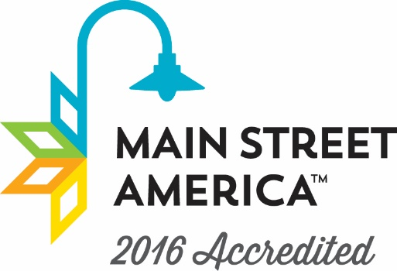
The National Main Street Center and Missouri Main Street Connection reaffirmed Downtown Lee’s Summit Main Street as a nationally and state accredited Main Street community. This is the highest level a downtown revitalization program can receive.
The Downtown Lee’s Summit Main Street organization is evaluated annually by Missouri Main Street Connection, which works in partnership with the National Main Street Center to identify the local programs that meet ten performance standards. These standards set the benchmarks for measuring an individual Main Street program’s application of the Main Street Four-Point Approach® to commercial district revitalization. Evaluation criteria determines the communities that are building comprehensive and sustainable revitalization efforts and include standards such as fostering strong public-private partnerships, tracking economic progress, preserving historic buildings and more.
Both Norma Ramirez de Miess, Senior Program Officer at the National Main Street Center, and Gayla Roten, State Director for Missouri Main Street Connection, congratulate Downtown Lee’s Summit on their achievement.
Ms. Miess noted that “Downtown Lee’s Summit continues to build upon past successes and creates new opportunities with strong leadership and volunteers from the community. It is exciting to see the impact of Main Street downtown with a low vacancy rate, popular events and future plans for a market and event pavilion.”
During 2016, Downtown Lee’s Summit saw 17 projects that resulted in over $1.4 million in public and private investment. The downtown district also saw 83 net new jobs and 3,907 volunteer hours.
The Missouri Main Street Program’s purpose is to create vibrant communities across the State. This effort is based on numerous recent studies showing that empowering individuals to develop their downtown motivates high achievement, making our state economically stronger. The goal of the Main Street Center and Missouri Main Street program is to encourage preservation-based economic development through the Main Street Four-Point Approach®.
Missouri Main Street Connection provides communities with the tools needed to develop into thriving downtowns. “These tools can be used to create jobs and build a sense of place that not only provides for current Missouri residents, but makes our communities more attractive to new residents and generations to come,” said Ms. Roten.
“It is truly an honor to receive national and state accreditation,” said Donnie Rodgers, executive director of Downtown Lee’s Summit Main Street. “National accreditation validates all of the hard work of our volunteers and community in making Downtown Lee’s Summit one of the greatest downtowns in the nation.”
Communities selected for the accreditation review are evaluated using the annual evaluation process and accreditation criteria intended to assist each community in performing up to national accreditation standards, as prescribed by the National Main Street Center. Though it is a critical moment for a Missouri Main Street community to become accredited, it is equally important for the community to maintain the accreditation status once it has been earned.

— END —

MEMBERS OF THE MEDIA (not for publication):
To reach DLSMS Executive Director Donnie Rodgers, Jr.: donnie@downtownls.org.
To reach DLSMS Assistant Director Ashley Nowell: ashley@downtownls.org.
To reach DLSMS Events & Promotions Director Julie Cook: julie@downtownls.org.
To reach DLSMS Communications Coordinator Jen Steller: jen@downtownls.org.
Or call 816-246-6598. High-resolution photos and logos available upon request.
ABOUT DOWNTOWN LEE’S SUMMIT:
Downtown Lee’s Summit is a multiple state and national award-winner for excellence in downtown revitalization, including the 2010 Great American Main Street Award®, which the National Trust Main Street Center gives to only five communities across the nation every year.
Rich in history, Downtown Lee’s Summit is listed on the National Register of Historic Places. Its strong ties to the railroad continue to this day — visitors can hop on a passenger train and arrive at the Amtrak station in Downtown Lee’s Summit for a memorable trip. With more than 50 distinctive retail shops, and many restaurants and bars ranging from upscale to laid-back, Downtown Lee’s Summit is an eclectic and fun place to visit. A unique combination of preservation of history and place, with progressive attitudes and entrepreneurship, make Downtown Lee’s Summit a great place to live, shop, eat and play.

