FOR IMMEDIATE RELEASE
November 14, 2016
Jen Steller | Communications Coordinator
jen@downtownLS.org | 816-246-6598
www.downtownLS.org

Mayor’s Tree Lighting, Santa’s Arrival is Friday, Nov. 18 in Downtown Lee’s Summit
Event Features Carriage Rides, Hot Apple Cider, Visits with Santa, and More
Lee’s Summit Mayor Randy Rhoads and Citizens of the Year, Nick and Jennie Swearngin, will flip the switch to light the Mayor’s Tree and all of Downtown Lee’s Summit on Friday, Nov. 18. This event is made possible by the support of Amtrak Missouri River Runner, Bank of Lee’s Summit, Lee’s Summit Journal and Google Fiber. The holiday lights will remain on through the first week in January.
The lights will be turned on at approximately 6:45 p.m. in Howard Station Park in Downtown Lee’s Summit, and Santa will arrive via fire truck immediately following. Master of Ceremonies for the evening will be Erin Little, Meteorologist with KMBC 9 News.
Free hot apple cider and cookies, provided by Lee’s Summit Community Church, will be served prior to the lighting, and children can begin lining up to visit Santa after 6 p.m.
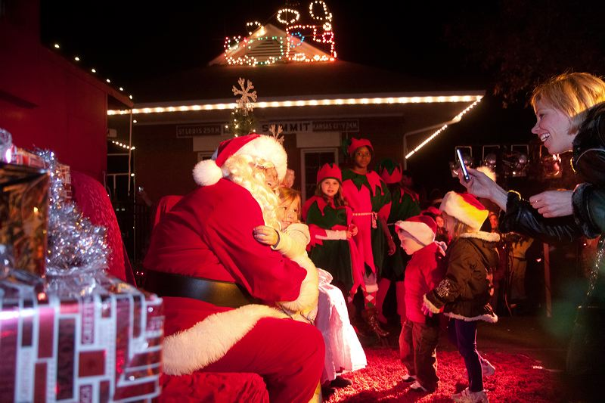
Prior to the lighting and Santa’s arrival, the Lee’s Summit Elementary School Cougar Choir will entertain the crowd with holiday favorites at 6:30 p.m.
Santa, Mrs. Claus and their elves will visit with children at Howard Station Park until approximately 9 p.m. Bring a camera to take photos with Santa. Carriage rides also will be offered for a small fee. Don’t forget to visit participating Downtown businesses, which will be open until 8 p.m. Friday, Nov. 18 for holiday shopping.

Participating businesses include:
- @jolly’s
- A Thyme for Everything
- Bar-istro
- Blue Heron Design
- The Cigar Room
- GOT Art Gallery
- Lee’s Summit Tribune
- The Living Stone
- Luxxe Apparel
- Razzberry Wimzy
- Red Door Wine Store
- The Sports Scene
- Summit Video Services
- Third Street Social
- Very Violet Boutique
- Wedding Expressions by Geri
- Whistle Stop Coffee

— END —

MEMBERS OF THE MEDIA (not for publication):
To reach DLSMS Executive Director Donnie Rodgers, Jr.: donnie@downtownls.org.
To reach DLSMS Assistant Director Ashley Nowell: ashley@downtownls.org.
To reach DLSMS Events & Promotions Director Julie Cook: julie@downtownls.org.
To reach DLSMS Communications Coordinator Jen Steller: jen@downtownls.org.
Or call 816-246-6598. High-resolution photos and logos available upon request.

ABOUT DOWNTOWN LEE’S SUMMIT:
Downtown Lee’s Summit is a multiple state and national award-winner for excellence in downtown revitalization, including the 2010 Great American Main Street Award®, which the National Trust Main Street Center gives to only five communities across the nation every year.
Rich in history, Downtown Lee’s Summit is listed on the National Register of Historic Places. Its strong ties to the railroad continue to this day — visitors can hop on a passenger train and arrive at the Amtrak station in Downtown Lee’s Summit for a memorable trip. With more than 40 distinctive retail shops, and many restaurants and bars ranging from upscale to laid-back, Downtown Lee’s Summit is an eclectic and fun place to visit. New residential lofts and adjacent historic neighborhoods also make Downtown Lee’s Summit an exceptional place to call home. A unique combination of preservation of history and place, with progressive attitudes and entrepreneurship, make Downtown Lee’s Summit a great place to live, shop, eat and play.

