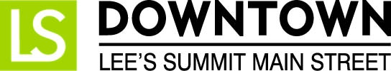
FOR IMMEDIATE RELEASE
December 15, 2016
Jen Steller | Communications Coordinator
jen@downtownLS.org | 816-246-6598
www.downtownLS.org
_____________________________________________________________________________________________
Collaboration is a Win-Win for Missouri Main Street Connection, Fossil Forge and Downtown Lee’s Summit Main Street

Missouri Main Street Connection (MMSC) unveiled their new branding and logo at the most recent Quarterly Workshop in Chillicothe, Missouri. The new brand is a product of collaboration between Downtown Lee’s Summit Main Street, Fossil Forge, and Missouri Main Street Connection.

As a follow up to their 10th anniversary year, MMSC asked the Executive Directors of their Main Street communities to seek out local design and marketing firms within their community who would submit logo and branding proposals for consideration as the new image of MMSC. When presenting the branding competition to the Main Street communities, MMSC asked that the new logo and brand showcase the spirit of Main Street in Missouri. As a reward, MMSC provided a $5,000 reward that would be given to the winning firm, to then be donated to the Main Street community where that firm is located.

A committee created by MMSC selected the winning design from a group of over ten submissions, and the winning design was one submitted by Fossil Forge on behalf of Downtown Lee’s Summit Main Street. Fossil Forge, a Lee’s Summit-based design firm, donated their time to help create the new brand.

Dave Eames, owner of Fossil Forge and a member of the Board of Directors for Downtown Lee’s Summit Main Street, said of the process, “We set out to create a fresh logo that represented the physical and human connection of the Missouri Main Street program and its communities. We were considerate of the current logo, thinking about how we might use existing elements in a new way.”

“Housed inside the outline of Missouri, the grid represents the roads, connections and intersections of our main streets and town squares. The colorful blocks between the lines are the prairies, forests, farms and rural patches of our state. The pattern of bricks and stone crisscross the logo, which are key building blocks to our modern and historic towns and cities.”

MMSC will begin using the new branding in 2017.
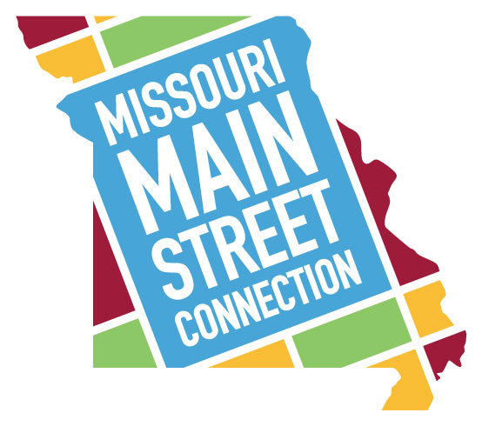
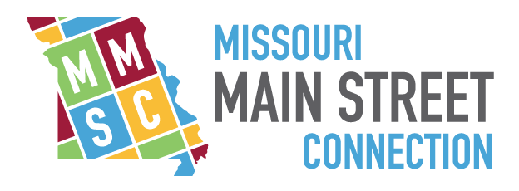

— END —

MEMBERS OF THE MEDIA (not for publication):
To reach DLSMS Executive Director Donnie Rodgers, Jr.: donnie@downtownls.org.
To reach DLSMS Assistant Director Ashley Nowell: ashley@downtownls.org.
To reach DLSMS Events & Promotions Director Julie Cook: julie@downtownls.org.
To reach DLSMS Communications Coordinator Jen Steller: jen@downtownls.org.
Or call 816-246-6598. High-resolution photos and logos available upon request.
ABOUT DOWNTOWN LEE’S SUMMIT:
Downtown Lee’s Summit is a multiple state and national award-winner for excellence in downtown revitalization, including the 2010 Great American Main Street Award®, which the National Trust Main Street Center gives to only five communities across the nation every year.
Rich in history, Downtown Lee’s Summit is listed on the National Register of Historic Places. Its strong ties to the railroad continue to this day — visitors can hop on a passenger train and arrive at the Amtrak station in Downtown Lee’s Summit for a memorable trip. With more than 40 distinctive retail shops, and many restaurants and bars ranging from upscale to laid-back, Downtown Lee’s Summit is an eclectic and fun place to visit. New residential lofts and adjacent historic neighborhoods also make Downtown Lee’s Summit an exceptional place to call home. A unique combination of preservation of history and place, with progressive attitudes and entrepreneurship, make Downtown Lee’s Summit a great place to live, shop, eat and play.

