FOR IMMEDIATE RELEASE
October 25, 2016
Jen Steller | Communications Coordinator
jen@downtownLS.org | 816-246-6598
www.downtownLS.org
_____________________________________________________________________________________________ ______________
Shop Outside the Box: Upcoming Holiday Events in Downtown Lee’s Summit
If you’re looking to create holiday traditions and memories this season while you do your holiday shopping in an inviting, unhurried and friendly atmosphere, visit Downtown Lee’s Summit to capture the magic of the holiday season. There is something for everyone including many upcoming holiday events that bring the community together and encourage shopping at over 75 unique, locally-owned shops and restaurants.

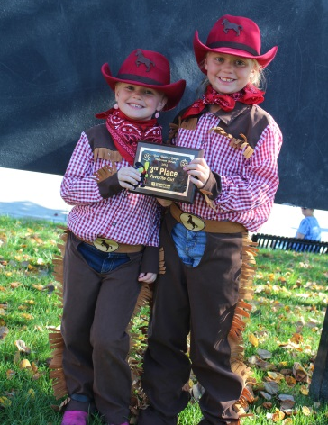
Boos, Barks & Badges Halloween Parade: Saturday, October 29
Families and their dogs are invited to wear costumes and join in the costume parade from City Hall Plaza to Howard Station Park. A costume contest will begin after the parade and includes plaques for the best costumes in the following categories: Favorite Boy, Favorite Girl, Favorite Pet, Favorite Family/Group, and Most Unique. After the parade, children are welcome to trick-or-treat at participating Downtown businesses. Parade line up is at City Hall Plaza beginning at 9:30a.m. and will include demonstrations by the Lee’s Summit K-9 Unit as well as complimentary bags for parade participants. This event is presented by Great Southern Bank and sponsored by Lee’s Summit Police Department and Lee’s Summit Fire Department.

Holiday Open House: Friday-Saturday, November 4-5
It’s time to start that holiday shopping! Head to Downtown Lee’s Summit on Nov. 4-5 for the Holiday Open House where the friendliest merchants around will help you find those perfect holiday gifts. Check out all the wonderful gift and decorating ideas featured in the shops in Downtown Lee’s Summit. Enjoy classes taught by local experts and business owners while shopping for the holidays. Customers can also enter to win a Downtown Lee’s Summit shopping spree! A free giftwrapping station will be provided at Budget Blinds from 12-4pm on Saturday, courtesy of Lee’s Summit Community Church.
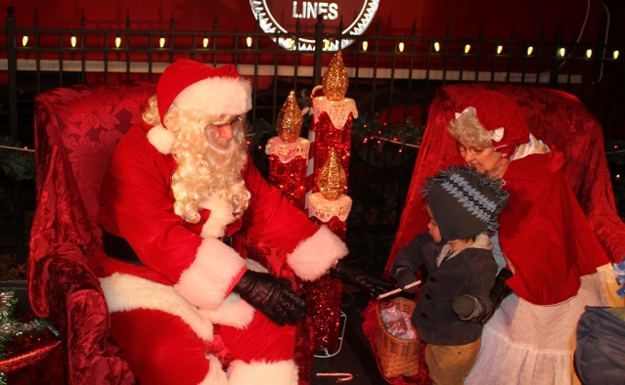
Mayor’s Tree Lighting: Friday, November 18
Lee’s Summit Mayor Randy Rhoads and the Lee’s Summit Citizens of the Year, Nick and Jennifer Swearngin, will flip the switch to light the Mayor’s Tree and all of Downtown Lee’s Summit in this annual celebration. The ceremonies begin at 6:30 p.m. in Howard Station Park in Downtown Lee’s Summit.
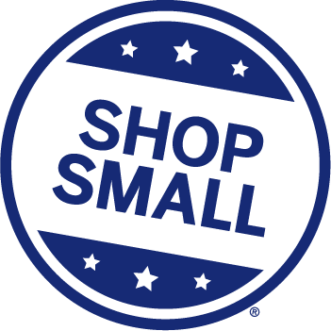
This year’s event features free hot cider, cookies and live music performances. Santa, Mrs. Claus and their elves arrive via fire truck to visit children at Howard Station Park, so bring a camera to take photos with Santa. Carriage rides will also be offered for a small fee. Don’t forget to visit participating Downtown businesses, which will be open until 8 p.m. This event is sponsored by Amtrak Missouri River Runner and Bank of Lee’s Summit.
Small Business Saturday: Saturday, November 26
Join us for this nationwide shopping event that encourages holiday shoppers to patronize brick and mortar businesses, focusing on those that are small and locally-owned. In addition to finding unique items to give as gifts (or keep for yourself), Downtown Lee’s Summit Main Street will be giving away great prizes like Amtrak tickets to Washington, MO with a stay at Gottfried’s Cabin, a prize package from downtown businesses, and $750 worth of Downtown Lee’s Summit gift cards.
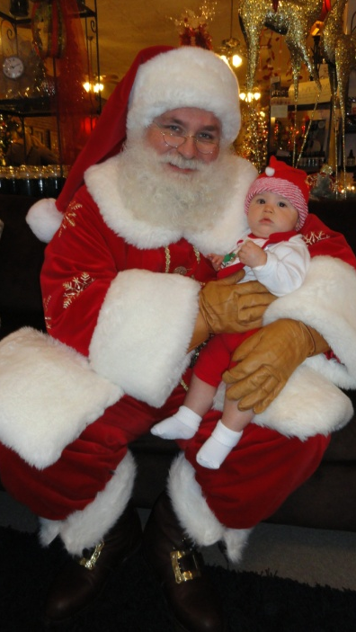
Santa Visits Downtown Lee’s Summit
As you shop Downtown Lee's Summit this holiday season, be sure to stop in to get your photos with Santa. He will be available for pictures with children of all ages during the following dates and times:
- Saturday, November 26 | Lee’s Summit History Museum, 220 SW Main St. | 2-4 p.m.
- Saturday, December 3 | Got Art Gallery, 18 SW 3rd St. | 3-5 p.m.
- Saturday, December 10 | Got Art Gallery, 18 SW 3rd St. | 3-5 p.m.
- Saturday, December 17 | Lee’s Summit History Museum, 220 SW Main St. | 2-4 p.m.
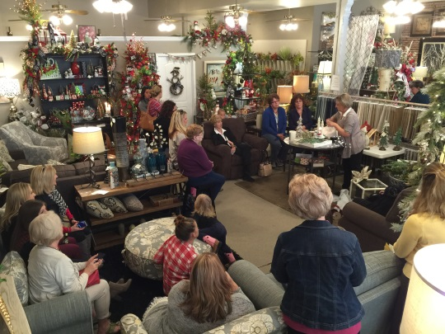
Hometown Holiday: Friday-Saturday, December 2-3
Participating shops will have holiday merchandise and gifts, perfect for crossing off the last items on your holiday shopping list. Enjoy classes taught by local experts and business owners while shopping for the holidays. Customers can also enter to win a Downtown Lee’s Summit shopping spree. A free giftwrapping station will be provided at Budget Blinds from 12-4pm on Saturday, courtesy of Lee’s Summit Community Church.
Farmers Market Holiday Mart: Saturday, December 17
Shop for in-season produce, handmade crafts, baked goods and more from the Downtown Lee’s Summit Farmers Market vendors. The annual indoor Farmers Market Holiday Mart from 9 a.m. to 2 p.m. Saturday, December 17, in the Lee’s Summit Elementary Gym, 110 SE Green St., Lee’s Summit.
The Downtown Lee’s Summit Farmers Market’s regular outdoor market also remains open from 7 a.m. to sell-out every Wednesday and Saturday through November 19, at the corner of Douglas and Second streets.

Free public parking for Downtown Lee’s Summit events is always available at the parking garage located at 2nd and Green streets.
—END—
MEMBERS OF THE MEDIA (not for publication):
To reach DLSMS Executive Director Donnie Rodgers, Jr.: donnie@downtownls.org.
To reach DLSMS Assistant Director Ashley Nowell: ashley@downtownls.org.
To reach DLSMS Events & Promotions Director Julie Cook: julie@downtownls.org.
To reach DLSMS Communications Coordinator Jen Steller: jen@downtownls.org.
Or call 816-246-6598. High-resolution photos and logos available upon request.
ABOUT DOWNTOWN LEE’S SUMMIT:
Downtown Lee’s Summit is a multiple state and national award-winner for excellence in downtown revitalization, including the 2010 Great American Main Street Award®, which the National Trust Main Street Center gives to only five communities across the nation every year.
Rich in history, Downtown Lee’s Summit is listed on the National Register of Historic Places. Its strong ties to the railroad continue to this day — visitors can hop on a passenger train and arrive at the Amtrak station in Downtown Lee’s Summit for a memorable trip. With more than 40 distinctive retail shops, and many restaurants and bars ranging from upscale to laid-back, Downtown Lee’s Summit is an eclectic and fun place to visit. New residential lofts and adjacent historic neighborhoods also make Downtown Lee’s Summit an exceptional place to call home. A unique combination of preservation of history and place, with progressive attitudes and entrepreneurship, make Downtown Lee’s Summit a great place to live, shop, eat and play.

