FOR IMMEDIATE RELEASE
February 7, 2017
Jen Steller | Communications Coordinator
jen@downtownLS.org | 816-246-6598
www.downtownLS.org
_____________________________________________________________________________________________
Shop Downtown Lee’s Summit to Welcome Spring
Annual Spring Open House Features Giveaways, Instructional Classes

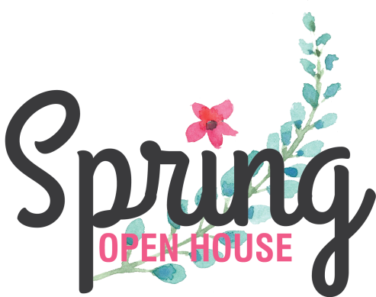
Downtown Lee’s Summit Main Street is hosting its annual Spring Open House from Friday through Saturday, March 3-4, during regular business hours of participating stores. Downtown businesses will feature Spring home décor, specialty gifts, clothing and more, which you can explore throughout the award-winning downtown.
During the event, customers are invited to visit each participating store to enter to win a Downtown Gift Basket and a $100 Downtown Lee’s Summit gift card.
Shoppers will also have a chance to attend instructional classes held at participating stores and taught by local business owners and subject-matter experts. A map including information on class schedules, entering the giveaway contest, and store hours will be available at each participating business.

— END —

MEMBERS OF THE MEDIA (not for publication):
To reach DLSMS Executive Director Donnie Rodgers, Jr.: donnie@downtownls.org.
To reach DLSMS Assistant Director Ashley Nowell: ashley@downtownls.org.
To reach DLSMS Events & Promotions Director Julie Cook: julie@downtownls.org.
To reach DLSMS Communications Coordinator Jen Steller: jen@downtownls.org.
Or call 816-246-6598. High-resolution photos and logos available upon request.
ABOUT DOWNTOWN LEE’S SUMMIT:
Downtown Lee’s Summit is a multiple state and national award-winner for excellence in downtown revitalization, including the 2010 Great American Main Street Award®, which the National Trust Main Street Center gives to only five communities across the nation every year.
Rich in history, Downtown Lee’s Summit is listed on the National Register of Historic Places. Its strong ties to the railroad continue to this day — visitors can hop on a passenger train and arrive at the Amtrak station in Downtown Lee’s Summit for a memorable trip. With more than 50 distinctive retail shops, and many restaurants and bars ranging from upscale to laid-back, Downtown Lee’s Summit is an eclectic and fun place to visit. A unique combination of preservation of history and place, with progressive attitudes and entrepreneurship, make Downtown Lee’s Summit a great place to live, shop, eat and play.

