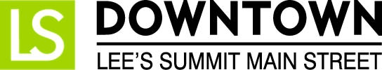
FOR IMMEDIATE RELEASE
April 18, 2017
Jen Steller | Communications Coordinator
jen@downtownLS.org | 816-246-6598
www.downtownLS.org

_____________________________________________________________________________________________

Crowdfunding Campaign to Bring Highly Desired Event to Downtown Lee’s Summit this Summer

The National Main Street Center, Project for Public Spaces, and ioby hosted the Cultivating Place on Main Streets Crowdfunding Challenge to award matching dollars to proposed placemaking projects in 5 states that focused on activating community spaces. Downtown Lee’s Summit Main Street, a 501c3 nonprofit organization focused on the preservation of historic Downtown Lee’s Summit, was selected as one of the pilot communities for this crowdfunding challenge. Funds for the placemaking project will be raised from public support through a crowdfunding campaign with the first $1,500 to be matched by ioby.

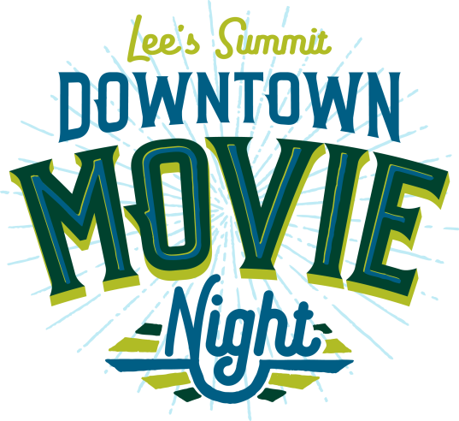
After receiving approval of the project, Downtown Lee’s Summit Main Street is excited to announce Downtown Movie Nights, to include three outdoor movie nights this summer that would be free to the public. The event will be hosted on the steps of City Hall Plaza once a month during evening hours and will activate an under-utilized area in our downtown.

Each movie night will feature a classic movie appropriate for all ages. Attendees will be encouraged to bring blankets, chairs, and picnics to enjoy during the event.

The crowdfunding campaign will be open to the public on Wednesday, April 19. Donations can be made online at the following link: bit.ly/DTLSmovies.

“Every dollar helps,” said DLSMS Assistant Director Ashley Nowell. “We were very excited to be chosen for this pilot project and hope that the community will rally around this event that people have been asking us to plan for years.”

If the funds are raised and the summer movie series is well received, Downtown Lee’s Summit Main Street will continue to host this event in subsequent years, with the hope of incorporating the series into the future performing arts and farmers market pavilion space downtown.

The movie night dates are as follows:

Thursday, July 27 | 9PM, sponsored by Midwest Property Resources, LLC
Thursday, August 24 | 8:30PM, sponsored by Arvest Bank
Thursday, September 28 | 8PM, sponsored by Douglas Auto and Tire

For more information on this and other Downtown Lee’s Summit events, visit www.downtownLS.org/events.

— END —

MEMBERS OF THE MEDIA (not for publication):
To reach DLSMS Executive Director Donnie Rodgers Jr.: donnie@downtownls.org.
To reach DLSMS Assistant Director Ashley Nowell: ashley@downtownls.org.
To reach DLSMS Events & Promotions Director Julie Cook: julie@downtownls.org.
To reach DLSMS Communications Coordinator Jen Steller: jen@downtownls.org.
Or call 816-246-6598. High-resolution photos and logos available upon request.
ABOUT THE CULTIVATING PLACE ON MAIN STREET CROWDFUNDING CHALLENGE:
In 2016, the National Main Street Center (NMSC) and Project for Public Spaces (PPS) launched Cultivating Place in Main Street Communities, a series of two-day trainings aimed at helping Main Street communities revitalize their downtowns using placemaking- a citizen-led process that helps activate downtowns and community gathering places. NMSC and PPS piloted this training program for Main Street communities in five states: Alabama, Connecticut, Missouri, Montana, and Oregon.
In 2017, NMSC is partnering with the national nonprofit crowdfunding platform, ioby, to offer matching funds, training, and one-on-one fundraising coaching to Main Street communities in those five pilot states. Fifteen projects from among these five pilot states have been selected for the pilot program.
ABOUT DOWNTOWN LEE’S SUMMIT MAIN STREET, INC.:
Downtown Lee’s Summit Main Street, Inc. is a nationally-recognized and accredited 501c3 nonprofit organization dedicated to the revitalization of Downtown Lee’s Summit. Founded in 1989, DLSMS implements the National Trust Main Street Center Four-Point Approach® to commercial district revitalization. DLSMS is a multiple state and national award-winner for excellence in downtown revitalization, including the 2010 Great American Main Street Award®, which the National Trust Main Street Center gives to only five communities across the nation every year.
ABOUT DOWNTOWN LEE’S SUMMIT:
Rich in history, Downtown Lee’s Summit is listed on the National Register of Historic Places. Its strong ties to the railroad continue to this day — visitors can hop on a passenger train and arrive at the Amtrak station in Downtown Lee’s Summit for a memorable trip. With more than 50 distinctive retail shops, and many restaurants and bars ranging from upscale to laid-back, Downtown Lee’s Summit is an eclectic and fun place to visit. Residential lofts and adjacent historic neighborhoods also make Downtown Lee’s Summit an exceptional place to call home. A unique combination of preservation of history and place, with progressive attitudes and entrepreneurship, make Downtown Lee’s Summit a great place to live, shop, eat and play.

