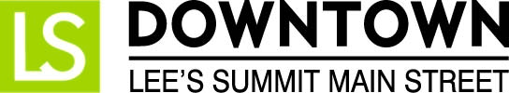
FOR IMMEDIATE RELEASE
June 15, 2017
Jen Steller | Communications Coordinator
jen@downtownLS.org | 816-246-6598
www.downtownLS.org

_____________________________________________________________________________________________

First-Ever Downtown Movie Nights Starting This Summer in Lee’s Summit

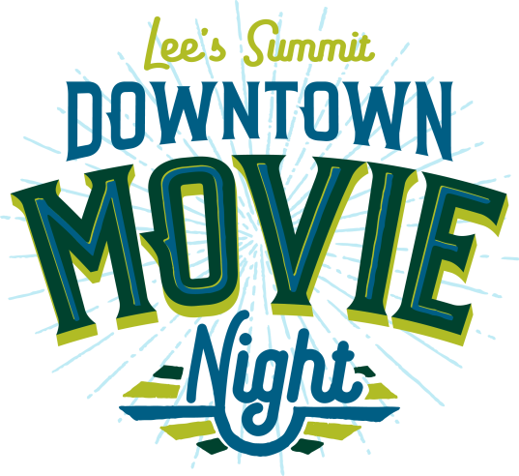
The National Main Street Center, Project for Public Spaces, and ioby hosted the Cultivating Place on Main Streets Crowdfunding Challenge to award matching dollars to proposed placemaking projects in 5 states that focused on activating community spaces. Downtown Lee’s Summit Main Street, a 501c3 nonprofit organization focused on the preservation of historic Downtown Lee’s Summit, was selected as one of the pilot communities for this crowdfunding challenge. Proposed funds for the placemaking project were raised from public support through a crowdfunding campaign, and the new event, Downtown Movie Night, will begin this summer.

The crowdfunding campaign raised $3,900 from almost 50 community members and businesses. $1,500 of that was matched by the hosts of the crowdfunding challenge, allowing $5,400 total to be devoted to the project. These funds will be used to buy the rights to the films and to purchase the necessary equipment for hosting outdoor movies.

Each movie night will feature a classic movie appropriate for all ages. Attendees are encouraged to bring blankets, chairs, and picnics to enjoy during the event. The event will be held in the City Hall Plaza area near 3rd and Green streets.

The Downtown Lee’s Summit Facebook page hosted a post to let the public vote on which movies would be shown. The dates and movies for the 2017 season are:

Thursday, July 27 | 9PM, Grease
Sponsored by Midwest Property Resources, LLC
Thursday, August 24 | 8:30PM, The Sandlot
Sponsored by Arvest Bank
Thursday, September 28 | 8PM, Princess Bride
Sponsored by Douglas Auto and Tire

For more information on this and other Downtown Lee’s Summit events, visit www.downtownLS.org/events.

— END —

MEMBERS OF THE MEDIA (not for publication):
To reach DLSMS Executive Director Donnie Rodgers Jr.: donnie@downtownls.org.
To reach DLSMS Assistant Director Ashley Nowell: ashley@downtownls.org.
To reach DLSMS Events & Promotions Director Julie Cook: julie@downtownls.org.
To reach DLSMS Communications Coordinator Jen Steller: jen@downtownls.org.
Or call 816-246-6598. High-resolution photos and logos available upon request.
ABOUT DOWNTOWN LEE’S SUMMIT MAIN STREET, INC.:
Downtown Lee’s Summit Main Street, Inc. is a nationally-recognized and accredited 501c3 nonprofit organization dedicated to the revitalization of Downtown Lee’s Summit. Founded in 1989, DLSMS implements the National Trust Main Street Center Four-Point Approach® to commercial district revitalization. DLSMS is a multiple state and national award-winner for excellence in downtown revitalization, including the 2010 Great American Main Street Award®, which the National Trust Main Street Center gives to only five communities across the nation every year.
ABOUT DOWNTOWN LEE’S SUMMIT:
Rich in history, Downtown Lee’s Summit is listed on the National Register of Historic Places. Its strong ties to the railroad continue to this day — visitors can hop on a passenger train and arrive at the Amtrak station in Downtown Lee’s Summit for a memorable trip. With more than 50 distinctive retail shops, and many restaurants and bars ranging from upscale to laid-back, Downtown Lee’s Summit is an eclectic and fun place to visit. Residential lofts and adjacent historic neighborhoods also make Downtown Lee’s Summit an exceptional place to call home. A unique combination of preservation of history and place, with progressive attitudes and entrepreneurship, make Downtown Lee’s Summit a great place to live, shop, eat and play.

