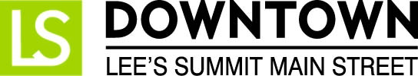
FOR IMMEDIATE RELEASE
January 24, 2017
Jen Steller | Communications Coordinator
jen@downtownLS.org | 816-246-6598
www.downtownLS.org

_____________________________________________________________________________________________

Downtown Lee’s Summit welcomes the annual Emerald Isle Parade, presented by Llywelyn’s Pub
Take part in activities throughout the day including an Irish Breakfast, Gold Coin Hunt, and a post-parade pub crawl.
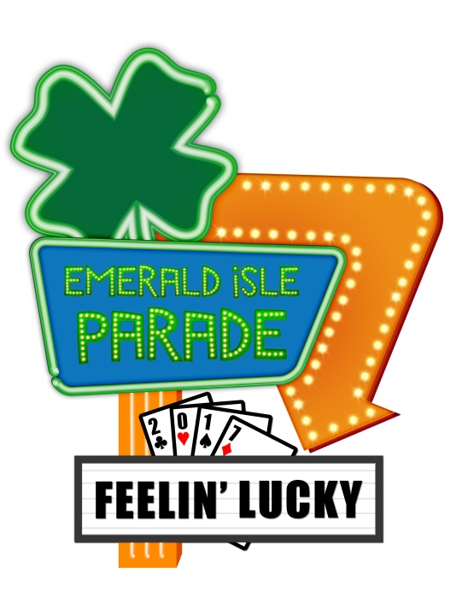
Celebrate all things Irish during the annual Emerald Isle Parade, which begins at noon Saturday, March 11, 2017 in Downtown Lee’s Summit. The popular parade and fun activities before and after take place the Saturday before St. Patrick’s Day. This year’s parade theme is “Feelin’ Lucky.”
Marching bands, color guards, dance teams, and some other entertainment groups will not be charged for their entries. All other groups pay a small fee to participate. If you are interested in having a float or entry in the parade, please contact Julie Cook at 816-246-6598 or julie@downtownls.org. The deadline for parade entry applications is February 24.
The Emerald Isle Parade, hosted by Downtown Lee’s Summit Main Street, is presented by Llywelyn’s Pub and sponsored by Amtrak/Missouri River Runner, Down to Earth Services, Lakewood Counseling/Truman Medical Center, Weed Man, and the Lee’s Summit Journal.
More information about the event can be found at www.downtownLS.org/events.

— END —

MEMBERS OF THE MEDIA (not for publication):
To reach DLSMS Executive Director Donnie Rodgers, Jr.: donnie@downtownls.org.
To reach DLSMS Assistant Director Ashley Nowell: ashley@downtownls.org.
To reach DLSMS Events & Promotions Director Julie Cook: julie@downtownls.org.
To reach DLSMS Communications Coordinator Jen Steller: jen@downtownls.org.
Or call 816-246-6598. High-resolution photos and logos available upon request.
ABOUT DOWNTOWN LEE’S SUMMIT:
Downtown Lee’s Summit is a multiple state and national award-winner for excellence in downtown revitalization, including the 2010 Great American Main Street Award®, which the National Trust Main Street Center gives to only five communities across the nation every year.
Rich in history, Downtown Lee’s Summit is listed on the National Register of Historic Places. Its strong ties to the railroad continue to this day — visitors can hop on a passenger train and arrive at the Amtrak station in Downtown Lee’s Summit for a memorable trip. With more than 50 distinctive retail shops, and many restaurants and bars ranging from upscale to laid-back, Downtown Lee’s Summit is an eclectic and fun place to visit. A unique combination of preservation of history and place, with progressive attitudes and entrepreneurship, make Downtown Lee’s Summit a great place to live, shop, eat and play.

