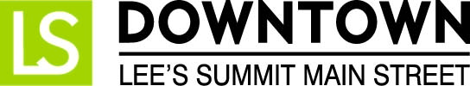
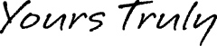
FOR IMMEDIATE RELEASE
February 26, 2017
Jen Steller | Communications Coordinator
jen@downtownLS.org | 816-246-6598
www.downtownLS.org

_____________________________________________________________________________________________

Emerald Isle Parade Details, Grand Marshal Announced

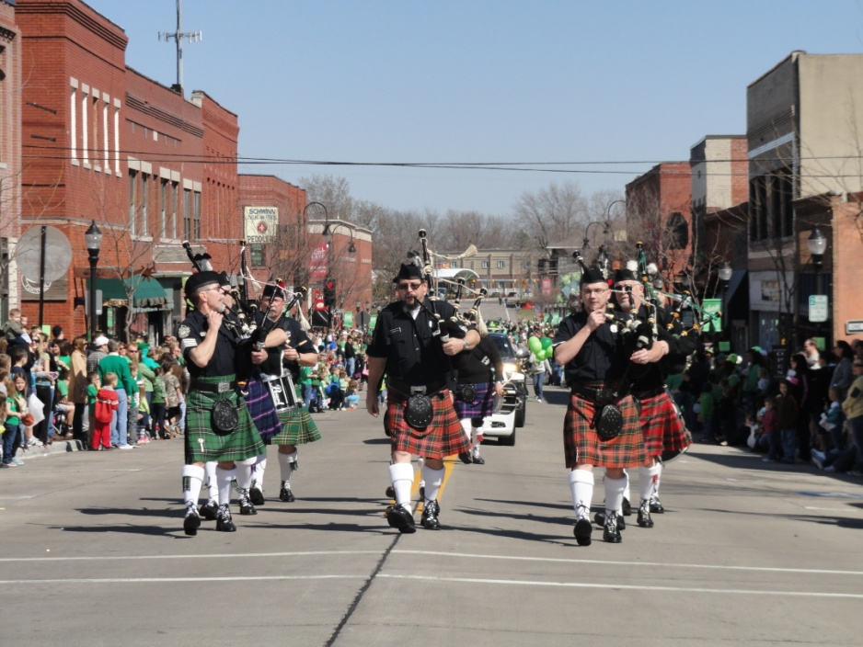
Celebrate all things Irish during the annual EMERALD ISLE PARADE, which begins at noon Saturday, March 11, in Downtown Lee’s Summit. The main parade route is on Green, Third and S.E. Main streets. The popular parade and fun activities before and after take place every year the Saturday before St. Patrick’s Day. This year’s Vegas inspired theme is “Feelin’ Lucky.”
The 2017 Emerald Isle Grand Marshal, Nancy Bruns, served as the Lee’s Summit Chamber of Commerce president from 2000-2016. “What an honor to be selected as this year's Grand Marshal,” Bruns said. “The Emerald Isle Parade is one of my favorite Lee’s Summit events, and I feel privileged to be chosen to lead the parade this year.”
Back this year (with a slight twist) is the Traditional Irish Breakfast, which will now take place the morning of the parade from 8 to 11 a.m. at Llywelyn’s Pub, 301 SE Douglas St. Tickets are $15 in advance, and $20 at the door and can be purchased at Llywelyn’s Pub Lee’s Summit location. Advanced tickets are recommended.
The Bits O’ Gold Coin Hunt takes place at 11:30 a.m. in Howard Station Park on SE Main Street. Children 8 and younger may participate in this race to find green and gold coins in the grass at Howard Station Park. No registration is necessary. Prizes will be awarded for children in each age group who find the rare golden coins.
More than 60 Downtown retail and specialty stores will be open throughout the day as they celebrate and showcase spring decor. Downtown restaurants and bars will feature their annual Emerald Isle Pub Crawl which will take place at approximately 1PM, following the parade, and will continue into the evening. To purchase an Emerald Isle Pub Crawl T-shirt or for more information, visit any Downtown Lee’s Summit bar or restaurant.
Judges for this year’s Emerald Isle Parade are Jason Lamb, sports reporter at WDAF-TV Fox 4; Chuck Denton, former Emerald Isle Parade grand marshal; and Jessica Kurzweil, former Emerald Isle committee member.
For more details, visit www.downtownLS.org/events.
The Emerald Isle Parade, is presented by Llywelyn’s Pub, and sponsored by TMC Lakewood Counseling, Amtrak Missouri RiverRunner, Weed Man, Down to Earth Services, Lee’s Summit Journal, and Downtown Lee’s Summit Main Street.

— END —

MEMBERS OF THE MEDIA (not for publication):
To reach DLSMS Executive Director Donnie Rodgers, Jr.: donnie@downtownls.org.
To reach DLSMS Assistant Director Ashley Nowell: ashley@downtownls.org.
To reach DLSMS Events & Promotions Director Julie Cook: julie@downtownls.org.
To reach DLSMS Communications Coordinator Jen Steller: jen@downtownls.org.
Or call 816-246-6598. High-resolution photos and logos available upon request.
ABOUT DOWNTOWN LEE’S SUMMIT:
Downtown Lee’s Summit is a multiple state and national award-winner for excellence in downtown revitalization, including the 2010 Great American Main Street Award®, which the National Trust Main Street Center gives to only five communities across the nation every year.
Rich in history, Downtown Lee’s Summit is listed on the National Register of Historic Places. Its strong ties to the railroad continue to this day — visitors can hop on a passenger train and arrive at the Amtrak station in Downtown Lee’s Summit for a memorable trip. With more than 50 distinctive retail shops, and many restaurants and bars ranging from upscale to laid-back, Downtown Lee’s Summit is an eclectic and fun place to visit. A unique combination of preservation of history and place, with progressive attitudes and entrepreneurship, make Downtown Lee’s Summit a great place to live, shop, eat and play.

