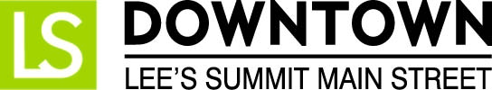
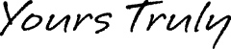
FOR IMMEDIATE RELEASE
April 10, 2017
Jen Steller | Communications Coordinator
jen@downtownLS.org | 816-246-6598
www.downtownLS.org

_____________________________________________________________________________________________

Downtown Lee’s Summit Bunny Hop is April 15

Grab your Easter basket, decorated bonnet or bunny ears, and hop on down to Downtown Lee’s Summit from 10 a.m. to Noon on Saturday, April 15, for the annual Downtown Bunny Hop. This free family activity includes a walking parade led by the Easter Bunny, an Easter Bonnet/Bunny Ears Contest, pictures with the Easter Bunny and free candy at participating downtown businesses, while supplies last.
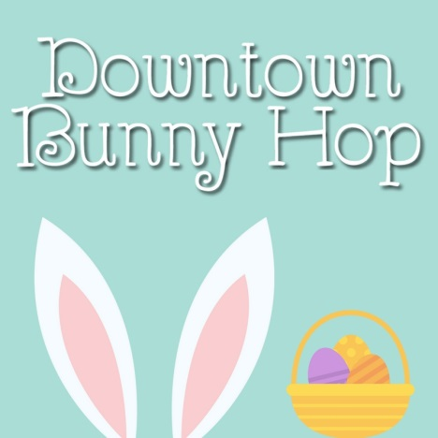
The parade line-up begins at 9:45 a.m. at City Hall Plaza, 220 SE Green St. in Downtown Lee’s Summit. At 10 a.m., the Easter Bunny, along with Lee’s Summit’s historic fire engine, will lead the parade up Third Street to Howard Station Park on SE Main Street.

Have your camera ready for pictures with the Easter Bunny immediately after the parade at Howard Station Park. Also following the parade, until noon, children can hop around to participating downtown businesses for free candy, while supplies last.

Be sure to decorate an Easter bonnet or hat for the Bunny Ears & Easter Hat Contest, taking place at 10:30 a.m. in Howard Station Park. Awards will be given to the best decorated bonnet or bunny ears in various age categories.

Convenient parking for the Bunny Hop can be found in the public parking garage at the corner of Second and Green streets.

The Downtown Bunny Hop is hosted by Downtown Lee’s Summit Main Street and made possible by the support of Heart of America Dance Centre, Jones Allery & Asthma Center, Renewal by Andersen, and Sky Zone Trampoline Park.
Sponsored by:
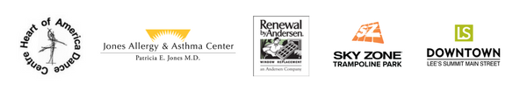

— END —

MEMBERS OF THE MEDIA (not for publication):
To reach DLSMS Executive Director Donnie Rodgers Jr.: donnie@downtownls.org.
To reach DLSMS Assistant Director Ashley Nowell: ashley@downtownls.org.
To reach DLSMS Events & Promotions Director Julie Cook: julie@downtownls.org.
To reach DLSMS Communications Coordinator Jen Steller: jen@downtownls.org.
Or call 816-246-6598. High-resolution photos and logos available upon request.
ABOUT DOWNTOWN LEE’S SUMMIT MAIN STREET, INC.:
Downtown Lee’s Summit Main Street, Inc. is a nationally-recognized and accredited 501c3 nonprofit organization dedicated to the revitalization of Downtown Lee’s Summit. Founded in 1989, DLSMS implements the National Trust Main Street Center Four-Point Approach® to commercial district revitalization. DLSMS is a multiple state and national award-winner for excellence in downtown revitalization, including the 2010 Great American Main Street Award®, which the National Trust Main Street Center gives to only five communities across the nation every year.
ABOUT DOWNTOWN LEE’S SUMMIT:
Rich in history, Downtown Lee’s Summit is listed on the National Register of Historic Places. Its strong ties to the railroad continue to this day — visitors can hop on a passenger train and arrive at the Amtrak station in Downtown Lee’s Summit for a memorable trip. With more than 50 distinctive retail shops, and many restaurants and bars ranging from upscale to laid-back, Downtown Lee’s Summit is an eclectic and fun place to visit. Residential lofts and adjacent historic neighborhoods also make Downtown Lee’s Summit an exceptional place to call home. A unique combination of preservation of history and place, with progressive attitudes and entrepreneurship, make Downtown Lee’s Summit a great place to live, shop, eat and play.

