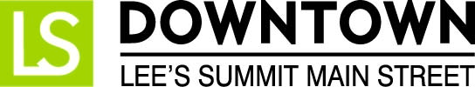
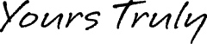

FOR IMMEDIATE RELEASE
October 13, 2016
Julie Cook | Events & Promotions Director
julie@downtownLS.org | 816-246-6598
www.downtownLS.org

Downtown Lee’s Summit Hosts Boos, Barks & Badges Halloween Parade
Event Features Costume Contest, Trick-or-Treating
and Displays by Lee’s Summit Police and Fire Departments
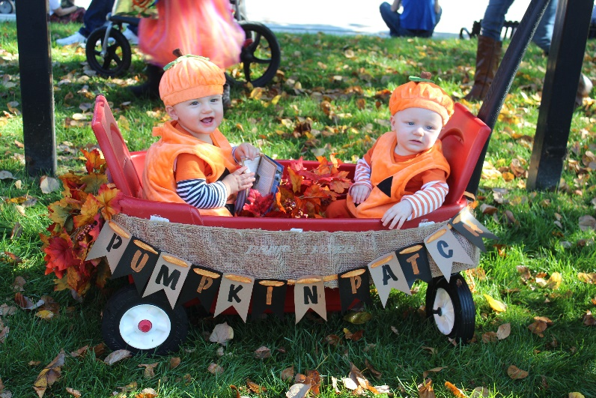
Downtown Lee’s Summit Main Street will host its annual Boos, Barks & Badges Halloween Parade on Saturday, October 29th. The event is presented by Great Southern Bank, and cosponsored by the Lee’s Summit Police and Fire Departments. Boos, Barks & Badges will feature displays from the Lee’s Summit Police and Fire Department’s K9 Unit, SWAT Team, Haz-Mat Unit, and more.
Families, children and pets are invited to put on their costumes and join the fun. Line-up for the parade begins at 9:30 a.m. at City Hall Plaza, 220 SE Green Street. Parade participants will get to see live demonstrations from the LSPD K9 Unit before the parade kicks off at 10 a.m. The parade will march west on Third Street to Howard Station Park.
Of course, no parade is complete without candy. After the parade, children are encouraged to trick-or-treat at participating downtown businesses from 10:15 a.m. to noon. A map of participating stores will be provided. Judging for the costume contest begins at 10:30 a.m. in Howard Station Park. Awards will be presented in five categories including Favorite Girl, Favorite Boy, Favorite Pet, Most Unique, and Favorite Family/Group.
Free parking is available at the City Hall Parking Garage located at 2nd and Green streets. The Lee’s Summit Fire Department is hosting an Open House at the fire station at 207 SE Douglas during the event, and all are welcome to attend.
Downtown Lee’s Summit Main Street is a 501c3 nonprofit organization dedicated to the revitalization and preservation of historic Downtown Lee’s Summit. For more information about this event or other upcoming Downtown Lee’s Summit events, visit www.downtownls.org/events.

MEMBERS OF THE MEDIA (not for publication):
To reach DLSMS Executive Director Donnie Rodgers, Jr.: donnie@downtownls.org.
To reach DLSMS Assistant Director Ashley Nowell: ashley@downtownls.org.
To reach DLSMS Events & Promotions Director Julie Cook: julie@downtownls.org.
To reach DLSMS Communications Coordinator Jen Steller: jen@downtownls.org.
Or call 816-246-6598. High-resolution photos and logos available upon request.

ABOUT DOWNTOWN LEE’S SUMMIT:
Downtown Lee’s Summit is a multiple state and national award-winner for excellence in downtown revitalization, including the 2010 Great American Main Street Award®, which the National Trust Main Street Center gives to only five communities across the nation every year.
Rich in history, Downtown Lee’s Summit is listed on the National Register of Historic Places. Its strong ties to the railroad continue to this day — visitors can hop on a passenger train and arrive at the Amtrak station in Downtown Lee’s Summit for a memorable trip. With more than 40 distinctive retail shops, and many restaurants and bars ranging from upscale to laid-back, Downtown Lee’s Summit is an eclectic and fun place to visit. New residential lofts and adjacent historic neighborhoods also make Downtown Lee’s Summit an exceptional place to call home. A unique combination of preservation of history and place, with progressive attitudes and entrepreneurship, make Downtown Lee’s Summit a great place to live, shop, eat and play.

